**CHAPTER 3**

**RESEARCH METHODS**

This chapter contains the methods in the development of St. Michael’s College Help Desk Web Application. The proponents followed the System Development Life Cycle (SDLC) in creating the project.

**Planning**

The proponents defined the objectives, scope and limitation of the study and come up with a web help desk project from the data gathered in St. Michael’s College. The proponents also projected the time frame and the project task to accomplish the planned features and functions.

|  |  |  |  |  |  |  |  |  |  |  |  |  |  |  |  |  |  |  |  |  |
| --- | --- | --- | --- | --- | --- | --- | --- | --- | --- | --- | --- | --- | --- | --- | --- | --- | --- | --- | --- | --- |
| **ACTIVITIES** | **JUNE** | | | | **JULY** | | | | **AUG** | | | | **SEPT** | | | | **OCT** | | | |
| **PLANNING** |  |  |  |  |  |  |  |  |  |  |  |  |  |  |  |  |  |  |  |  | |
| Data Gathering |  |  |  |  |  |  |  |  |  |  |  |  |  |  |  |  |  |  |  |  | |
| Identify Problems |  |  |  |  |  |  |  |  |  |  |  |  |  |  |  |  |  |  |  |  | |
| **ANALYSIS** |  |  |  |  |  |  |  |  |  |  |  |  |  |  |  |  |  |  |  |  | |
| Acquire System requirements |  |  |  |  |  |  |  |  |  |  |  |  |  |  |  |  |  |  |  |  | |
| Making Context Diagram |  |  |  |  |  |  |  |  |  |  |  |  |  |  |  |  |  |  |  |  | |
| Making Data Flow Diagram |  |  |  |  |  |  |  |  |  |  |  |  |  |  |  |  |  |  |  |  | |
| Making Entity Relationship Diagram |  |  |  |  |  |  |  |  |  |  |  |  |  |  |  |  |  |  |  |  | |
| Review proposal |  |  |  |  |  |  |  |  |  |  |  |  |  |  |  |  |  |  |  |  | |
| Finalize scope of work |  |  |  |  |  |  |  |  |  |  |  |  |  |  |  |  |  |  |  |  | |

**Table 3.1. Gantt Chart**

**Analysis**

In this phase, the proponents develop an organized representation of the process that occurs in help desk web application. The proponents make a Context Diagram, Data Flow Diagram and Entity Relationship Diagram to visualize the flow of the system.

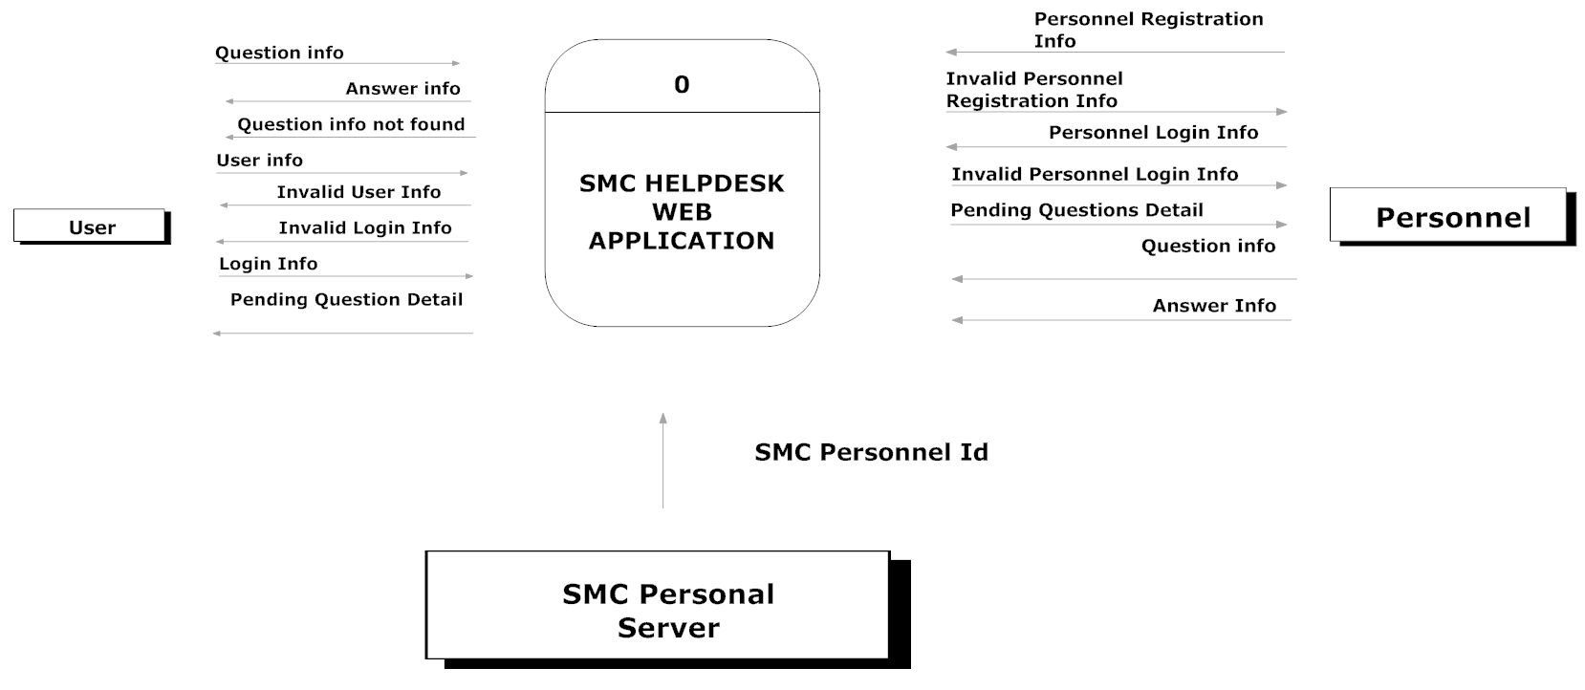

**Fig. 3.1 Context Diagram**

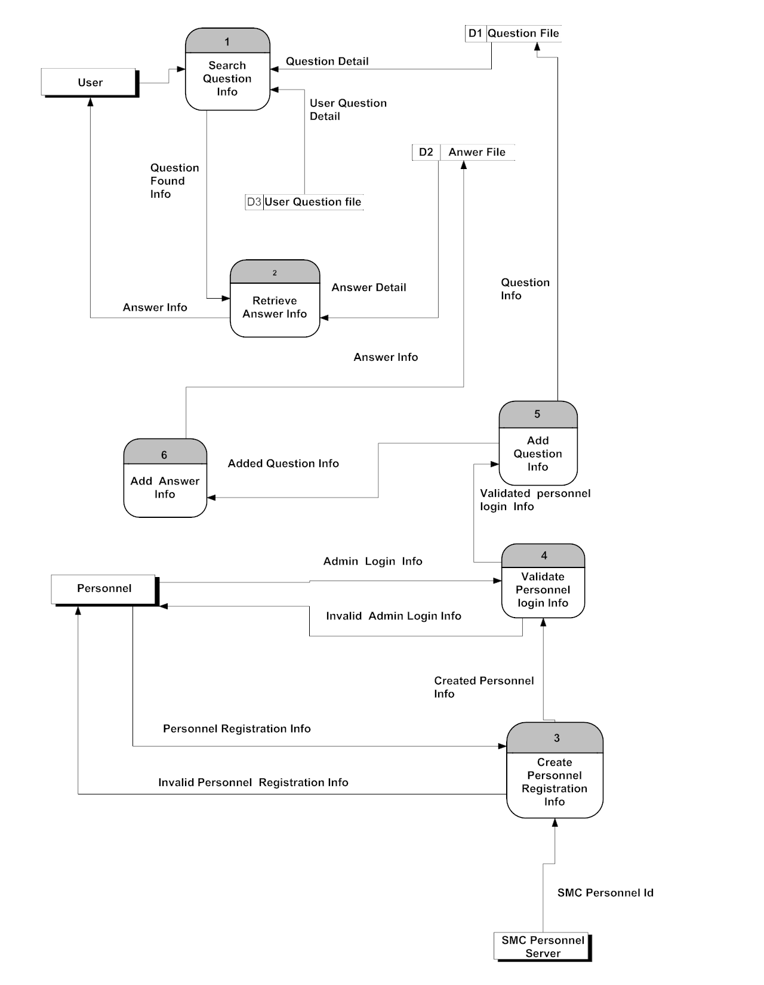

**Fig. 3.2 Data Flow Diagram**

***Answer Exist***

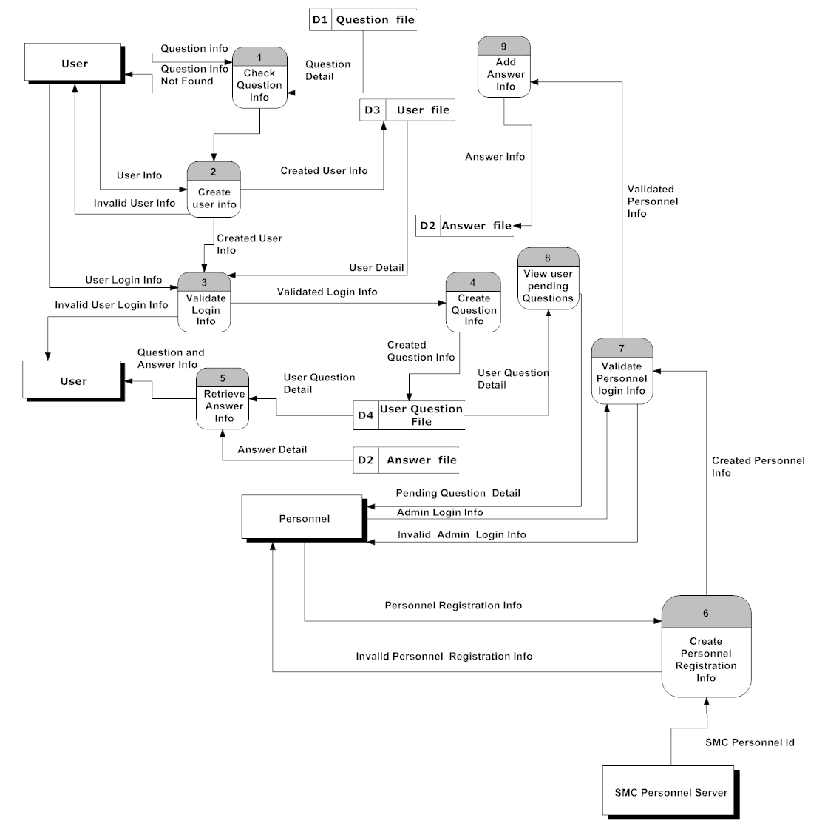

**Fig. 3.3 Data Flow Diagram**

***Answer not existing and required to register or login***

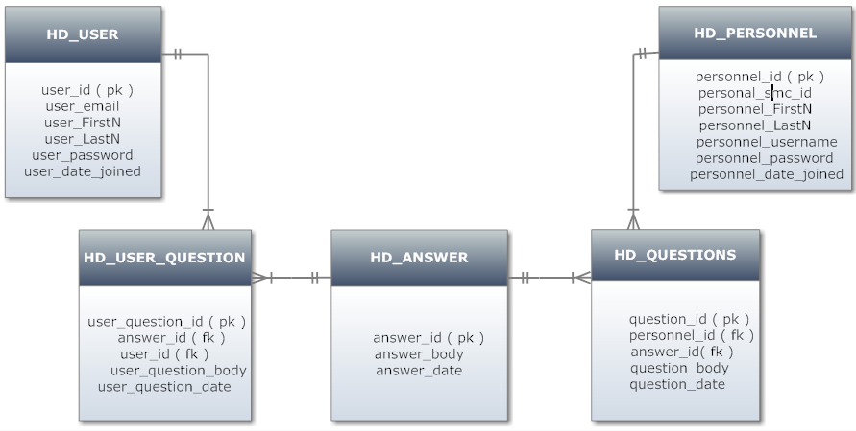

**Fig. 3.4 Entity-Relationship Diagram**

**Design­**

In this phase, after system requirements is being defined and visualized in diagrams, all important data of the system and its processes is identified.

SMC Help Desk Web Application is designed as a great tool for the students and visitors to unload their school-related questions and inquiries. The proponents will develop an online help desk that is centralized and can be an accessible source in real-time that will cater the needs of everyone regarding the school information. The answers that are going to be used in the application are based on the frequently asked questions which is stored in the database. This application is also like an online handbook that answers the question more detailed. This handbook-like application has other features that can give users detailed information through linking variety of images, audios and other details that can be shown in the end users page. The researchers will develop a simple and clean user interface, and easy to use features and functions for the convenience of the users. The proponents have also designed the application that has a capability to store questions that are not found in the database and notify the personnel through email. And these pending questions will be answered by personnel and will be added to validated question and answer database and ready to use in future with the same questions. By making these, the proponents came up with a Data Dictionary, which holds all the data that coming in and out of the system. It is where all information are being grouped, defined and identified what type of data is it.

**Data Dictionary**

|  |  |  |  |
| --- | --- | --- | --- |
| **Name** | **Type** | **Length** | **Description** |
| user_id | int | 11 | Unique id of the user |
| user_email | varchar | 25 | Email of the user |
| user_FirstN | vicar | 20 | First name of the user |
| user_LastN | varchar | 20 | Last name of the user |
| user_password | varchar | 20 | Password of the user |
| User_date_joined | date | Null | User date joined |

**Table 3.2 HD_User**

This table shows the user information that send inquiries or questions. It has the id of the each user that holds the details of every person. It contains the complete name of the user, its email, password and date when they joined.

|  |  |  |  |
| --- | --- | --- | --- |
| **Name** | **Type** | **Length** | **Description** |
| user_question_id | int | 11 | Unique id of the user question |
| answer_id | int | 11 | Unique id of the answer |
| user_id | int | 11 | Unique id of the user |
| user_question_body | varchar | 11 | Body of the question |
| user_question_date | date | 200 | Date when user asked question |

**Table 3.3 HD_User_Questions**

This table shows the information of the questions being sent or asked by the user. It has the unique id of the user who asked the questions, the question and the answer. It has date to record when it was asked.

|  |  |  |  |
| --- | --- | --- | --- |
| **Name** | **Type** | **Length** | **Description** |
| Question_id | int | 11 | Unique id of the question |
| Personnel_id | int | 11 | Unique id of the personnel |
| Answer_id | int | 11 | Unique id of the answer |
| Question_body | varchar | 200 | Body of the question |
| Question_date | date | null | Date of the question saved by the personnel |

**Table 3.4 HD_Questions**

This table holds the information of the questions being saved in the database by the personnel-in-charge. Every question has a unique id and corresponding id for the answers. It has also information of the personnel who inputted the questions and date when it was added.

|  |  |  |  |
| --- | --- | --- | --- |
| **Name** | **Type** | **Length** | **Description** |
| answer_id | int | 11 | Unique id of the question |
| answer_body | varchar | 200 | Body of the answer |
| answer_date | date | null | Date of the answer saved by the personnel |

**Table 3.5 HD_Answers**

This table shows the information of the answers which corresponds to the questions that is saved in the database. It has an id of each answer, the answer information and its date.

**Development**

The aim of this project is to develop a help desk web application that can allow the students to ask any related questions and be able to answer by the system without time consuming. The system will be developed with clean and simple user interface to use it easily.

This help desk web application will be evaluated after the project is completed; all the important data of the school and activities were recorded and documented a reference for future studies related to this system. These data have explained how the web application is operated or how it was used.

An evaluation will be conducted to test the effectiveness of the web application, how it meet the objectives of the study and how it helps in providing information to all interested students and visitors of St. Michael’s College.

The application required with at least minimum hardware and software requirements to implement it successfully and seamlessly.

*Hardware Requirements:*

-Intel Celeron

- 1GB RAM

- 40GB HDD

- monitor

- Keyboard

- Mouse

*Software Requirements:*

-Web browser (IE, Mozilla Firefox, Google Chrome, etc.)

- Internet connection

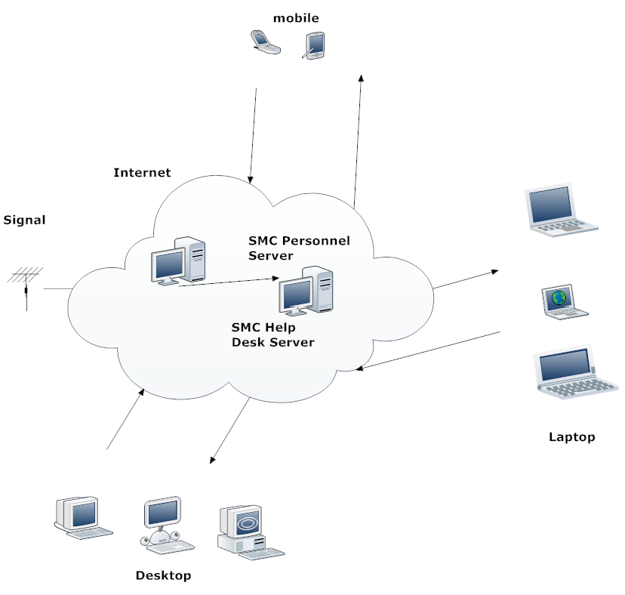

**Fig. 3. 5 Conceptual Framework**

The proponents will design the application according to its conceptual framework. This figure illustrates that the process will start from the end users’ devices such as desktops, laptops, smart phones, or other devices that has a web browser. The arrows represent the transmission of data from user to server. The SMC Personnel Server holds the information of the personnel in charge to monitor and add questions and answers and give answers to the pending questions of the users. The SMC Help Desk Server is the server that holds all the questions and answers being saved by the personnel in charge. It also contains the user information of the persons who access the web application. The internet shows that the system is only accessible when it has internet connection and also, has a signal.

**Testing Procedures**